1-npm

📦 What Is npm?
# Source: AI Source: Provided by: [Data Path: Persons Table -> ID Column: 1, Name_En Column: Motasem Essam] -> From: [Chatgpt (GPT‑5 Mini)] on [1/26/2026]
npm stands for Node Package Manager — it’s the default package manager for Node.js. It allows developers to install, share, and manage code packages (JavaScript libraries or tools) from the npm registry.

✅ Simple Definition:
# Source: AI Source: Provided by: [Data Path: Persons Table -> ID Column: 1, Name_En Column: Motasem Essam] -> From: [Chatgpt (GPT‑5 Mini)] on [1/26/2026]
npm helps JavaScript developers manage third-party code — like libraries, tools, and dependencies — and run scripts for building, testing, and deploying apps.

🧠 Real-Life Analogy:
# Source: AI Source: Provided by: [Data Path: Persons Table -> ID Column: 1, Name_En Column: Motasem Essam] -> From: [Chatgpt (GPT‑5 Mini)] on [1/26/2026]
Think of npm like an app store for JavaScript:
- You can install tools (e.g. React, Vue, Axios)
- You can publish your own packages
- It helps you organize your project’s dependencies

🔧 Key Features
# Source: AI Source: Provided by: [Data Path: Persons Table -> ID Column: 1, Name_En Column: Motasem Essam] -> From: [Chatgpt (GPT‑5 Mini)] on [1/26/2026]
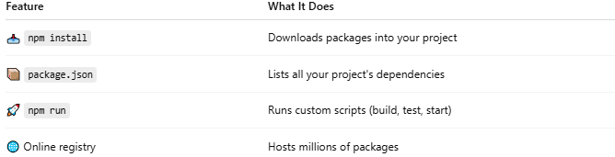

Feature | What It Does
📥 npm install | Downloads packages into your project
📦 package.json | Lists all your project's dependencies
🚀 npm run | Runs custom scripts (build, test, start)
🌐 Online registry | Hosts millions of packages

🛠️ How It's Used

✅ Installing a package
# Source: AI Source: Provided by: [Data Path: Persons Table -> ID Column: 1, Name_En Column: Motasem Essam] -> From: [Chatgpt (GPT‑5 Mini)] on [1/26/2026]
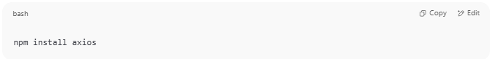
npm install axios

✅ Creating a package.json file
# Source: AI Source: Provided by: [Data Path: Persons Table -> ID Column: 1, Name_En Column: Motasem Essam] -> From: [Chatgpt (GPT‑5 Mini)] on [1/26/2026]
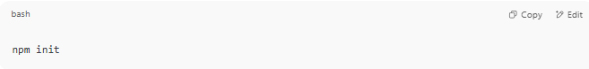
npm init

✅ Running a build script
# Source: AI Source: Provided by: [Data Path: Persons Table -> ID Column: 1, Name_En Column: Motasem Essam] -> From: [Chatgpt (GPT‑5 Mini)] on [1/26/2026]
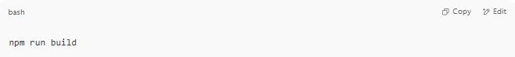
npm run build

📦 What Is the package.json File?
# Source: AI Source: Provided by: [Data Path: Persons Table -> ID Column: 1, Name_En Column: Motasem Essam] -> From: [Chatgpt (GPT‑5 Mini)] on [1/26/2026]
This file tracks:
- Your dependencies
- Project name and version
- Scripts (e.g., start server, build app)
- Metadata (author, license, etc.)
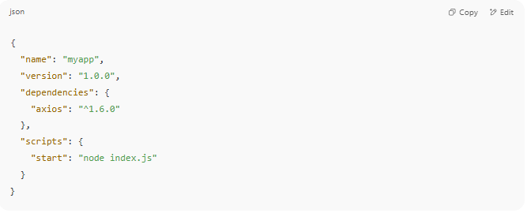
{
"name": "myapp",
"version": "1.0.0",
"dependencies": {
"axios": "^1.6.0"
},
"scripts": {
"start": "node index.js"
}
}

📌 Summary
# Source: AI Source: Provided by: [Data Path: Persons Table -> ID Column: 1, Name_En Column: Motasem Essam] -> From: [Chatgpt (GPT‑5 Mini)] on [1/26/2026]
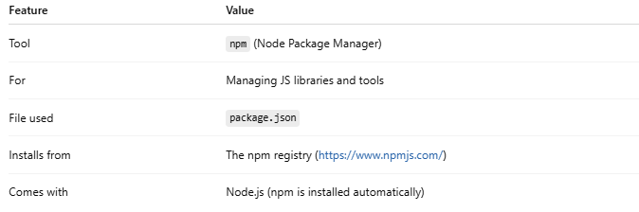

Feature | Value
Tool | npm (Node Package Manager)
For | Managing JS libraries and tools
File used | package.json
Installs from | The npm registry (https://www.npmjs.com/)
Comes with | Node.js (npm is installed automatically)

